|  |  |  |
| --- | --- | --- |
|  | **KATOWICE INSTITUTE OF TECHNOLOGIES**  **INFORMATION TECHOLOGY** |  |

**IT SYSTEM DESIGN**

**SYSTEM DESIGN REPORT**

**SUBJECT**

The Web Application for Patients, Lab Technicians and Doctors

To Manage Diseases and Access Pathological and Diagnostic Reports

**PREPARER**

09466

Kerim Senturk

**CONSULTANT**

Mr. Jacek Żywczok

1. PROJECT SCOPE 3

1.1. What is The Project? 3

1.2. What is The Purpose of Project? 3

1.3. What are The Components of Project? 3

1.4. What are The Functionalities of Project? 4

2. COMPONENTS 4

1.1. Database 4

1.1.1. Entities 4

(1) Disease 4

(2) Disease State Flow 5

(3) Report 6

(4) User 6

(5) Report File 8

1.1.2. Developing Tools 8

(1) MySQL 8

(2) Spring JPA Repository 8

1.2. Web API 9

1.2.1. User Service 9

1.2.2. Disease Service 9

1.2.3. Report Service 9

1.2.4. Report File Manager 10

1.2.5. Authentication 10

1.2.6. Developing Tools 12

(1) Java 19 12

(2) Spring Boot 12

(3) OpenAPI 12

(4) Maven 12

(5) IntelliJ IDEA 12

1.3. Web Interface User Manual 13

1.3.1. Pages 13

(1) Login 13

(2) Register 14

(3) Patient Dashboard 15

(4) User Drop-Down 16

(5) User Profile 17

(6) Update User 17

(7) Are You Sure Modal 18

(8) Doctor Dashboard 20

(9) Create Disease 21

(10) Create Diagnostic Report 21

(11) Update Diagnostic Report 22

(12) Lab Technician Dashboard 23

(13) Create Pathologic Report 24

(14) Update Pathologic Report 25

(15) My Reports 26

1.3.2. Developing Tools 27

(1) Javascript 27

(2) React.js 27

(3) Bootstrap 27

(4) Flaticon 27

(5) FontAwesome 27

(6) React-Toastify 27

3. USER AUTHORIZATION 28

4. FILE STRUCTURE 29

1.4. Web API 29

1.5. Web UI 30

1. PROJECT SCOPE
   1. What is The Project?

This project contains a web information management system to store, manage and present information about diseases of patients. It has report management system inside to manage diagnostic and pathologic reports. We have 4 types of user at this system;

*Patient*: A person who wants to examine their own diseases, pathology and diagnostic reports.

*Lab* Techinician: A person who performs lab requests created by doctor for patients and enters pathologic reports to the system.

*Doctor*: A person who deals with patients and creates diseases, lab requests, diagnostic reports for them.

*Admin*: A person who manages the all system. It has full authorize.

* 1. What is The Purpose of Project?
* Managing diseases of patients.
* To get easier managing and accessing pathologic and diagnostic reports.
* To get easier and be faster the accessing the patient results.
* Taking to digital place the patient diseases.
  1. What are The Components of Project?
* Database
* Web API
* Web Interface

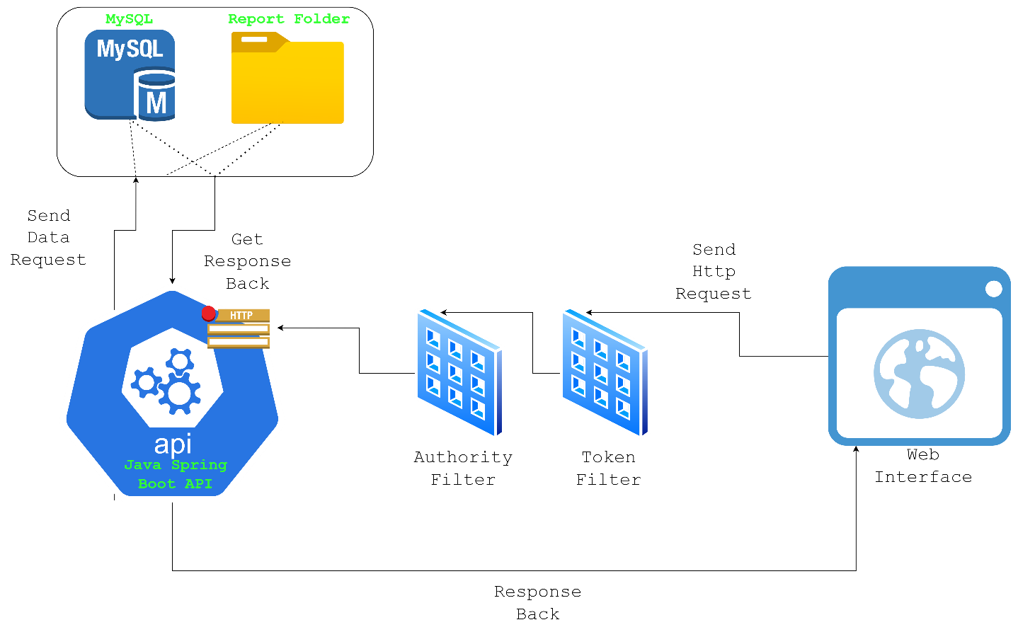

* 1. What are The Functionalities of Project?
* Create Patient/Lab Technician/Doctor User
* Update Patient/Lab Technician/Doctor Informations
* User Authentication by Login/Logout
* User Authorization by Authorization Manager
* Create, Update, Delete, View pathologic and diagnostic results of patients.
* Download Patient Results as .pdf file
* Managing diseases for patients.
* View disease state as live

*** Some of these functionalities can be perform only by who has authority. For more information check the “USER AUTHORIZATION”.

1. COMPONENTS
   1. Database
      1. Entities
         1. Disease

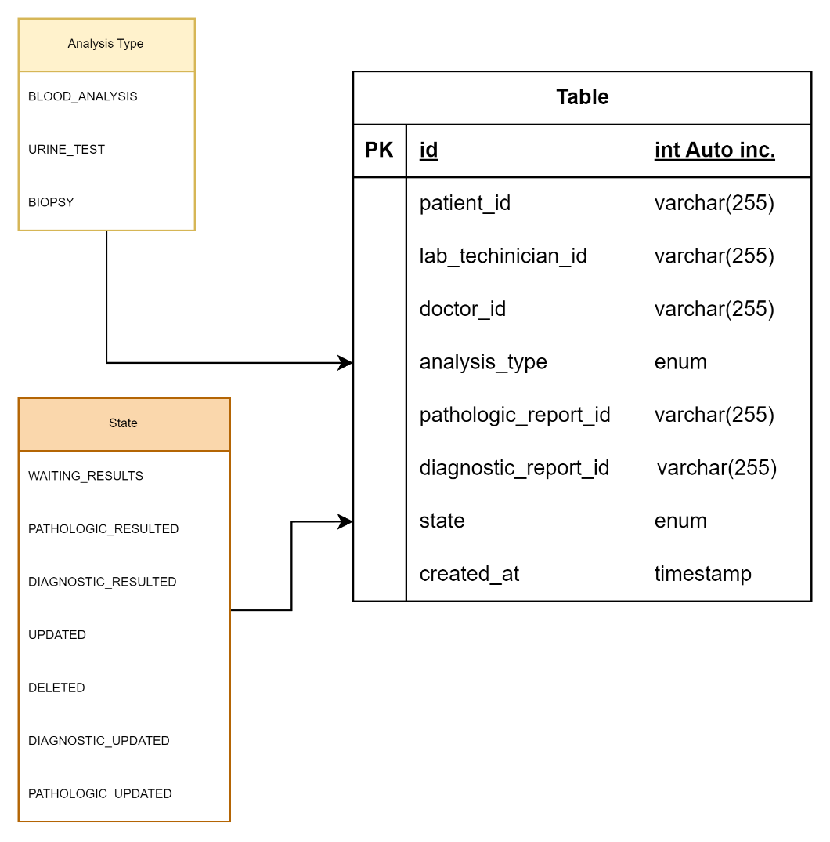

* + - 1. Disease State Flow

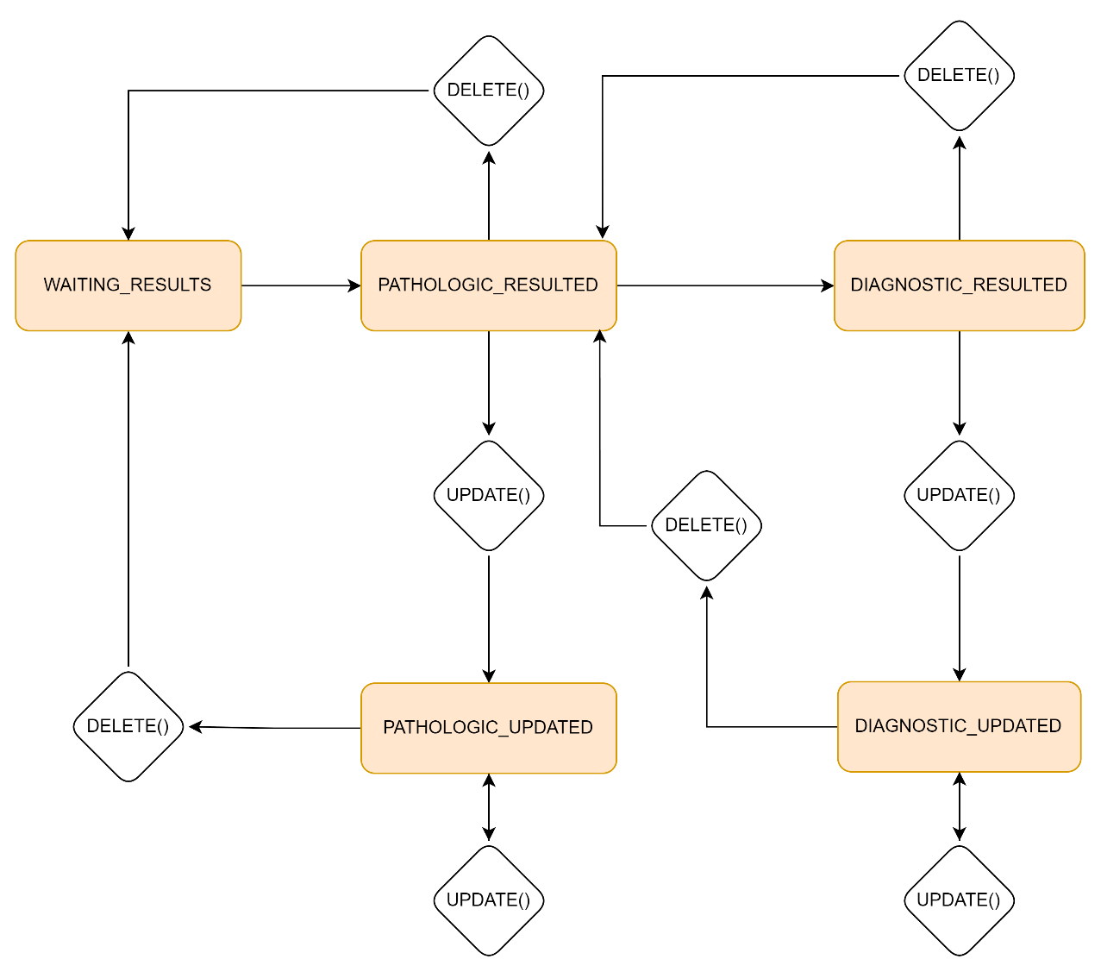

* + - 1. Report

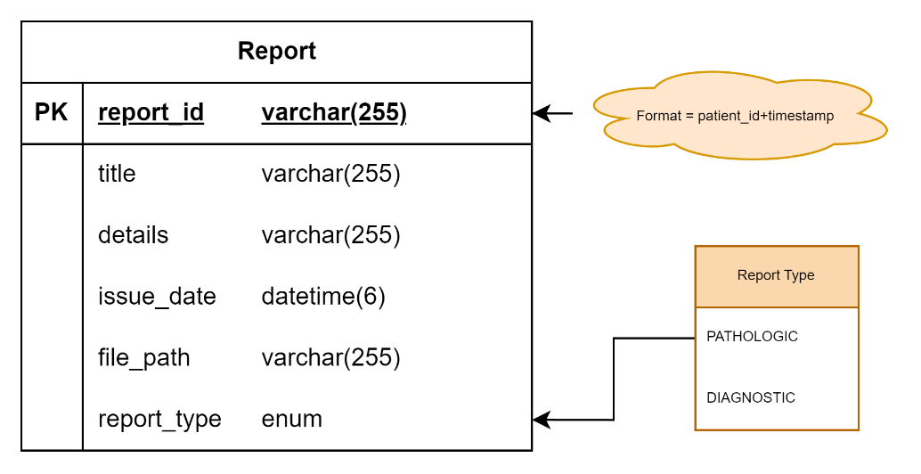

* + - 1. User

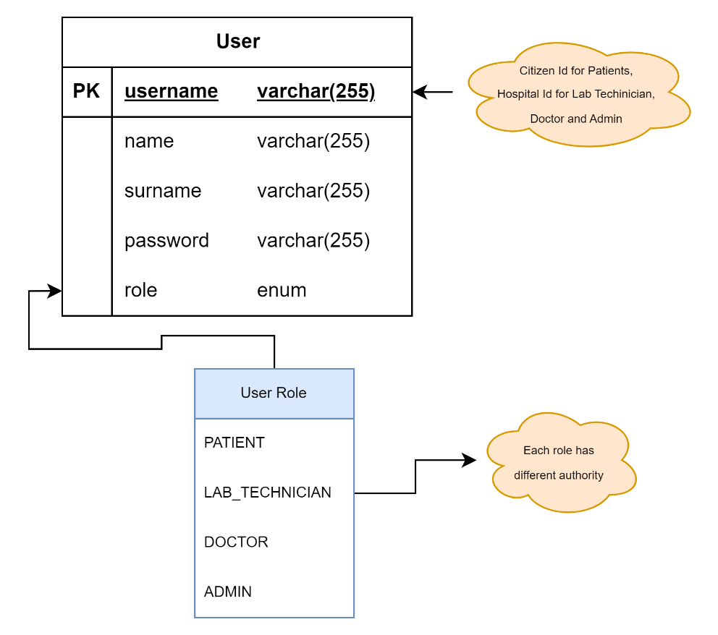

* + - 1. Report File

This report file creating by using disease and report entities. It has following properties;

* Report_number
* Result (title, details)
* Issue_Date
* Report_type
* Patient_id
* Doctor_name
* Lab_Techinician_name

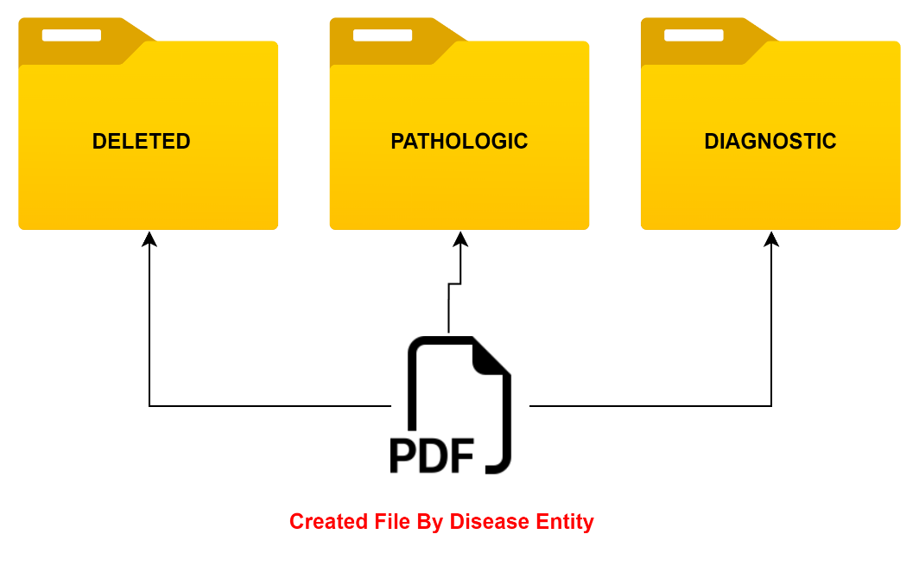

* + 1. Developing Tools
       1. MySQL

Patient, doctor and lab techinican informations stores here.

* + - 1. Spring JPA Repository

An ORM technoligies for Spring boot to create and manage database.

* 1. Web API
     1. User Service

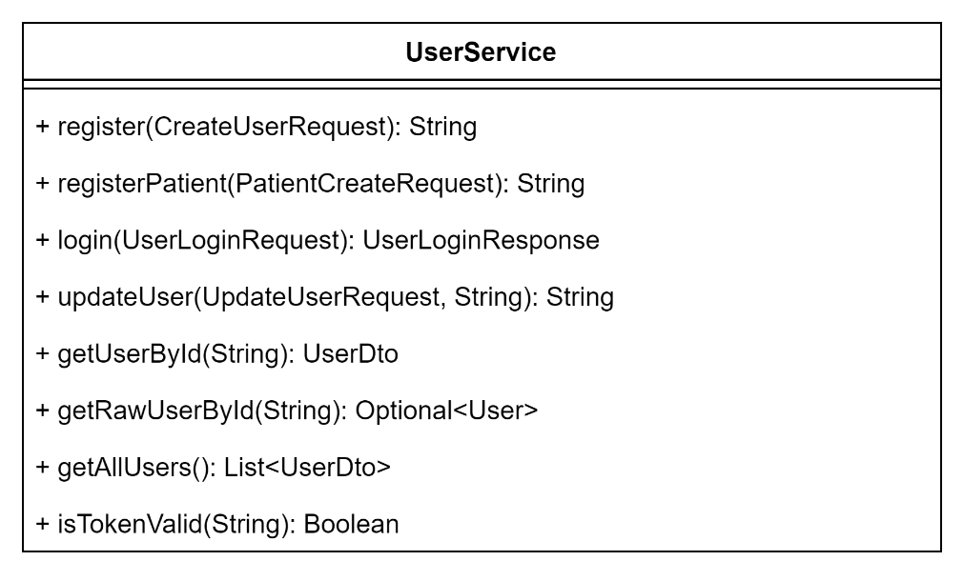

* + 1. Disease Service

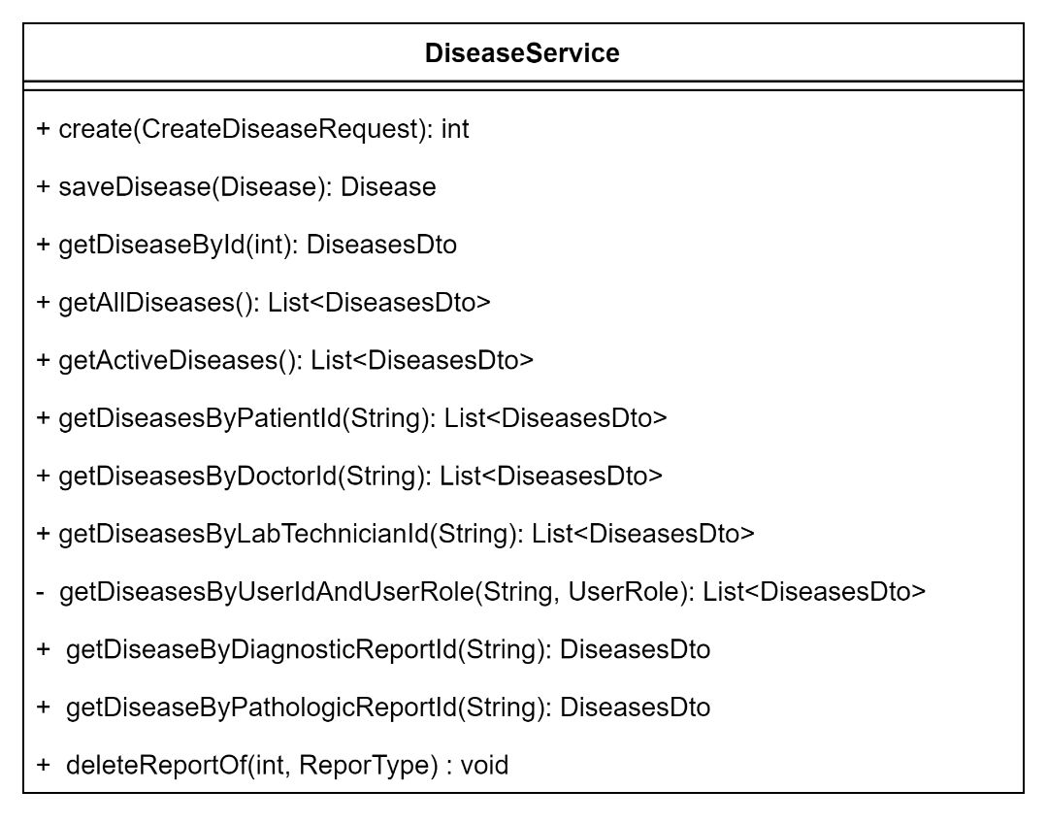

* + 1. Report Service

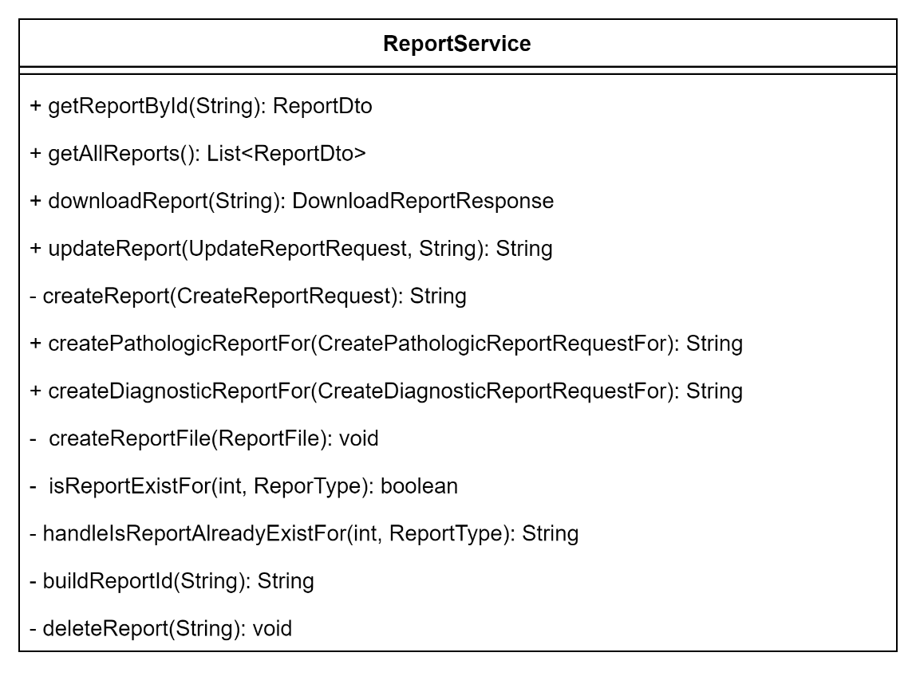

* + 1. Report File Manager

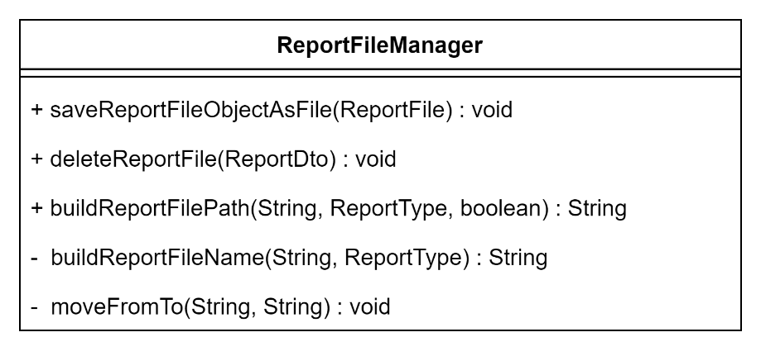

* + 1. Authentication

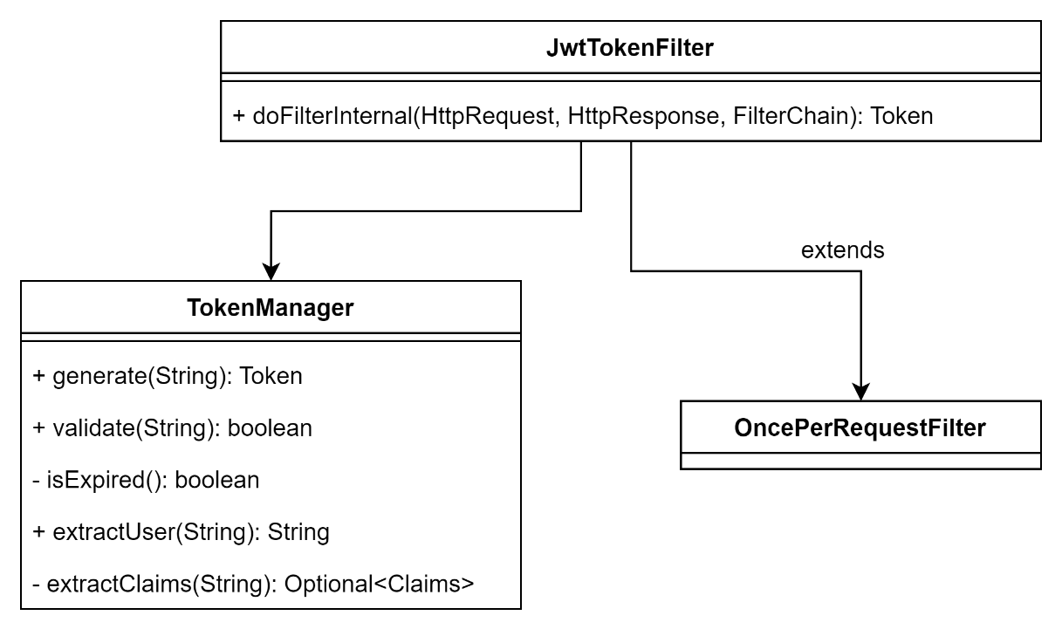

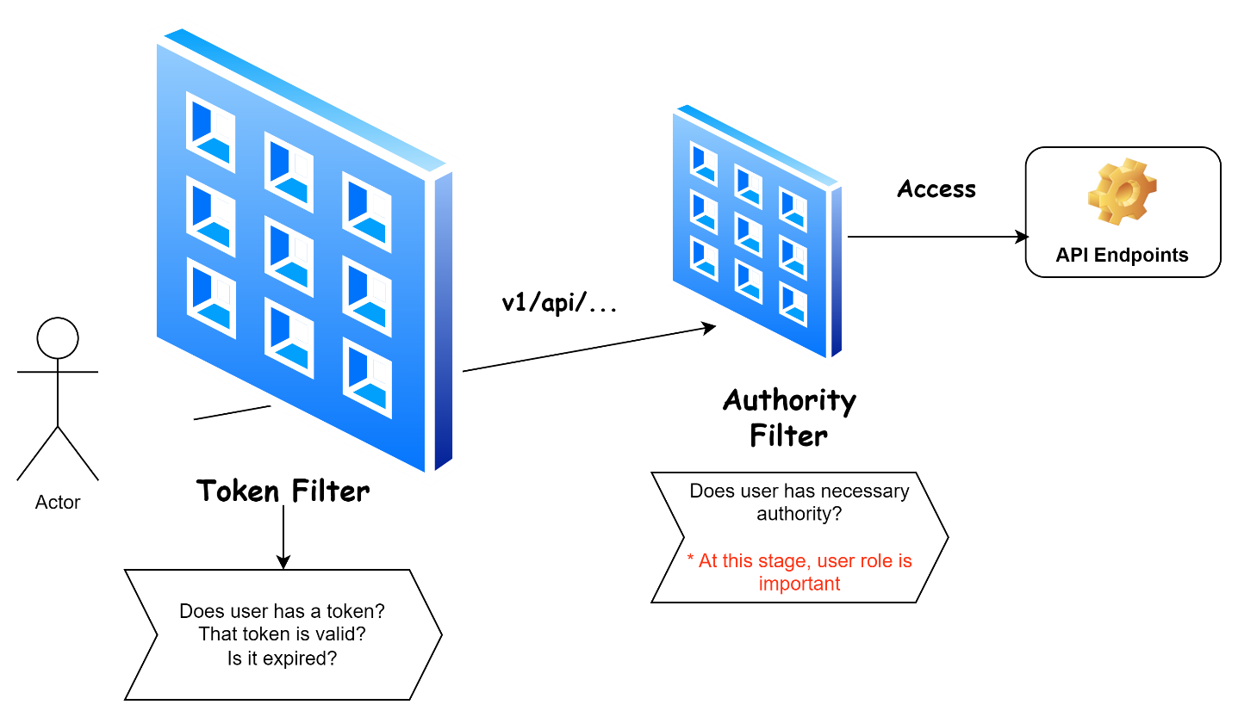

* + 1. Developing Tools
       1. Java 19

This language is the core of the Web API. Whole programming will do by this OOP lang.

* + - 1. Spring Boot

Spring Boot is a Java based framework to develop web projects. It has various module inside to create a web project. Spring-test, spring-web, spring-security, spring-aop, spring-jpa, spring-messging, spring-webmvc, spring-jdbc are some of these modules.

* + - 1. OpenAPI

OpenAPI is a tool to document endpoints of an API. In this way we can easily test and view our endpoints.

* + - 1. Maven

Maven is a dependency manager. Sometimes we need some libraries. At this stage maven downloads the needed libraries from Maven Repository and adds it to project for us.

* + - 1. IntelliJ IDEA

Intellij IDEA is a famous IDE for programming Java. It has various tools inside. Version Control System is one of these.

* 1. Web Interface User Manual
     1. Pages
        1. Login

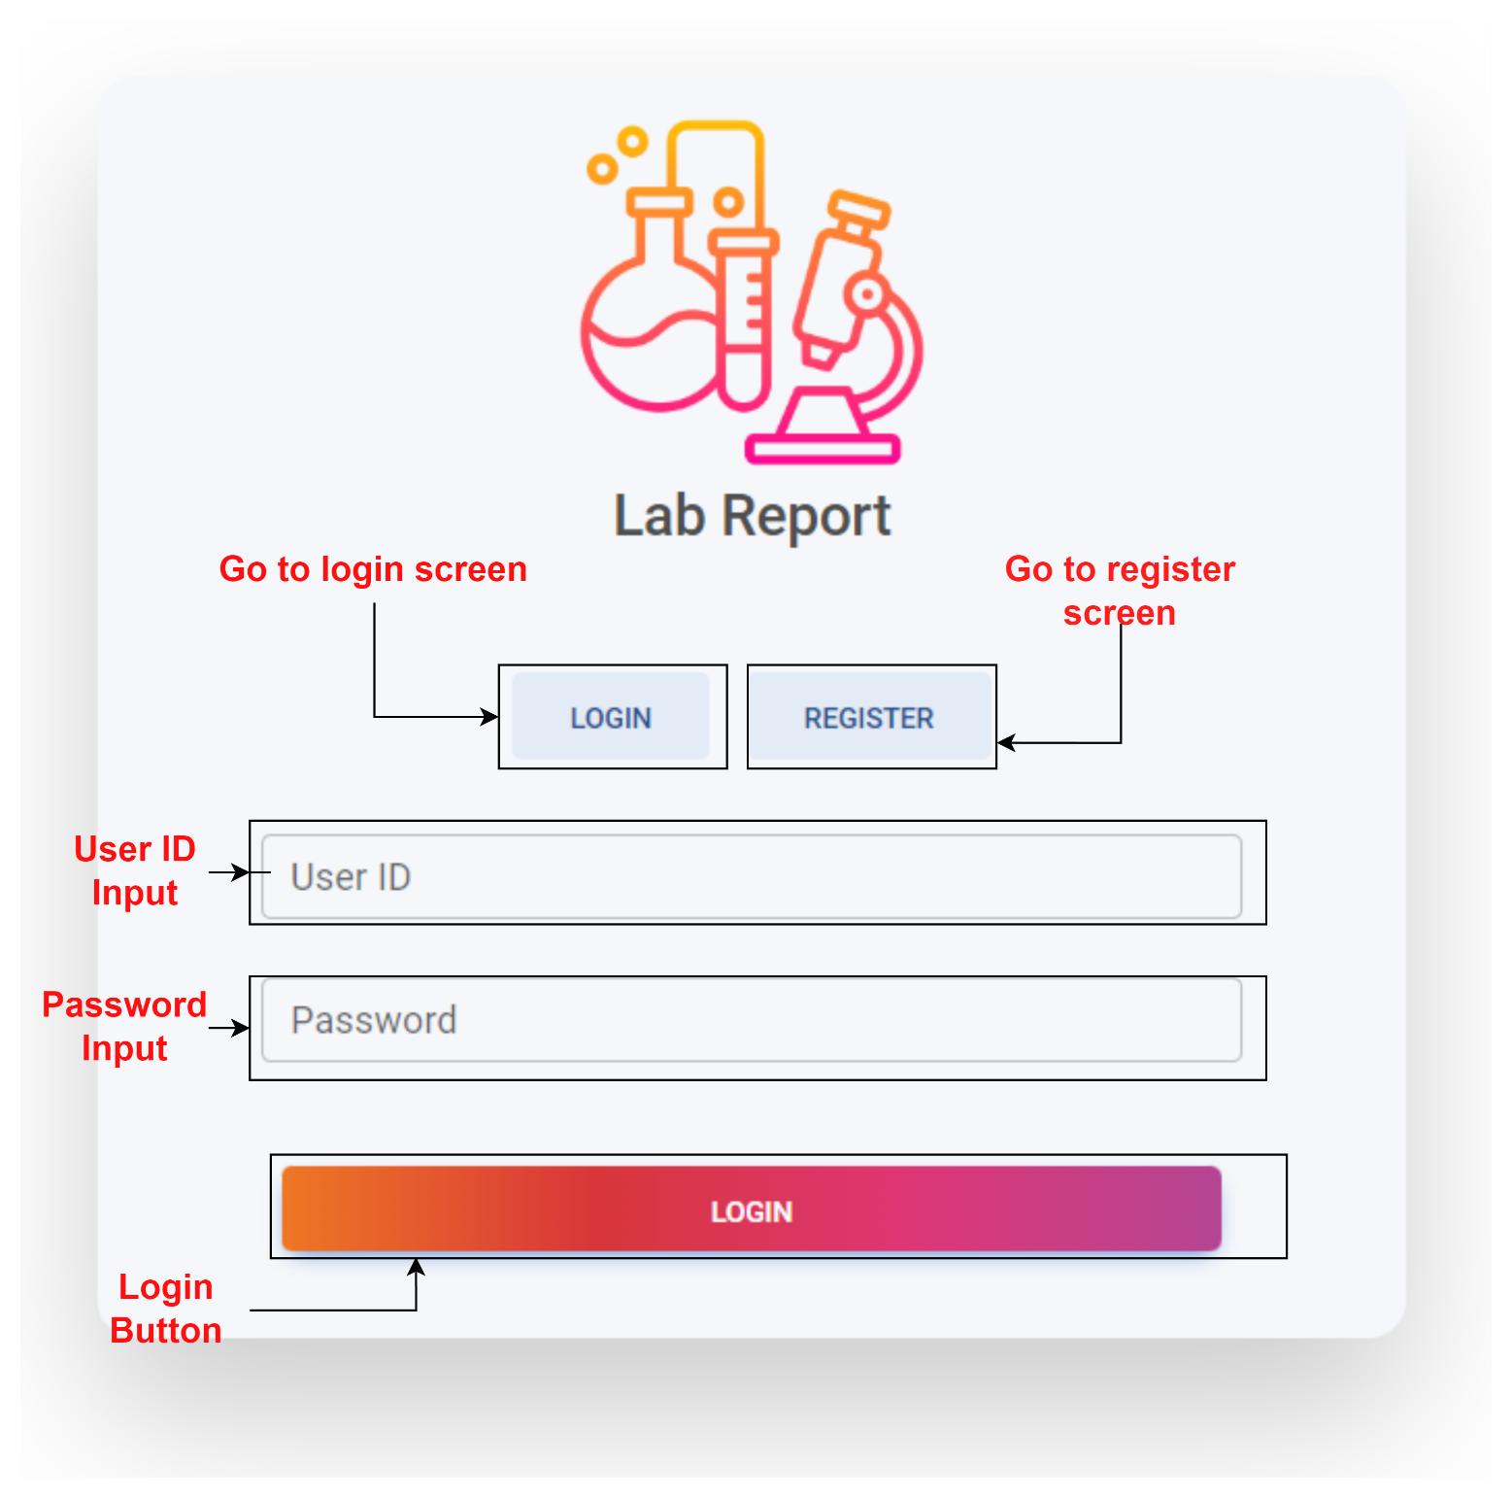

* + - 1. Register

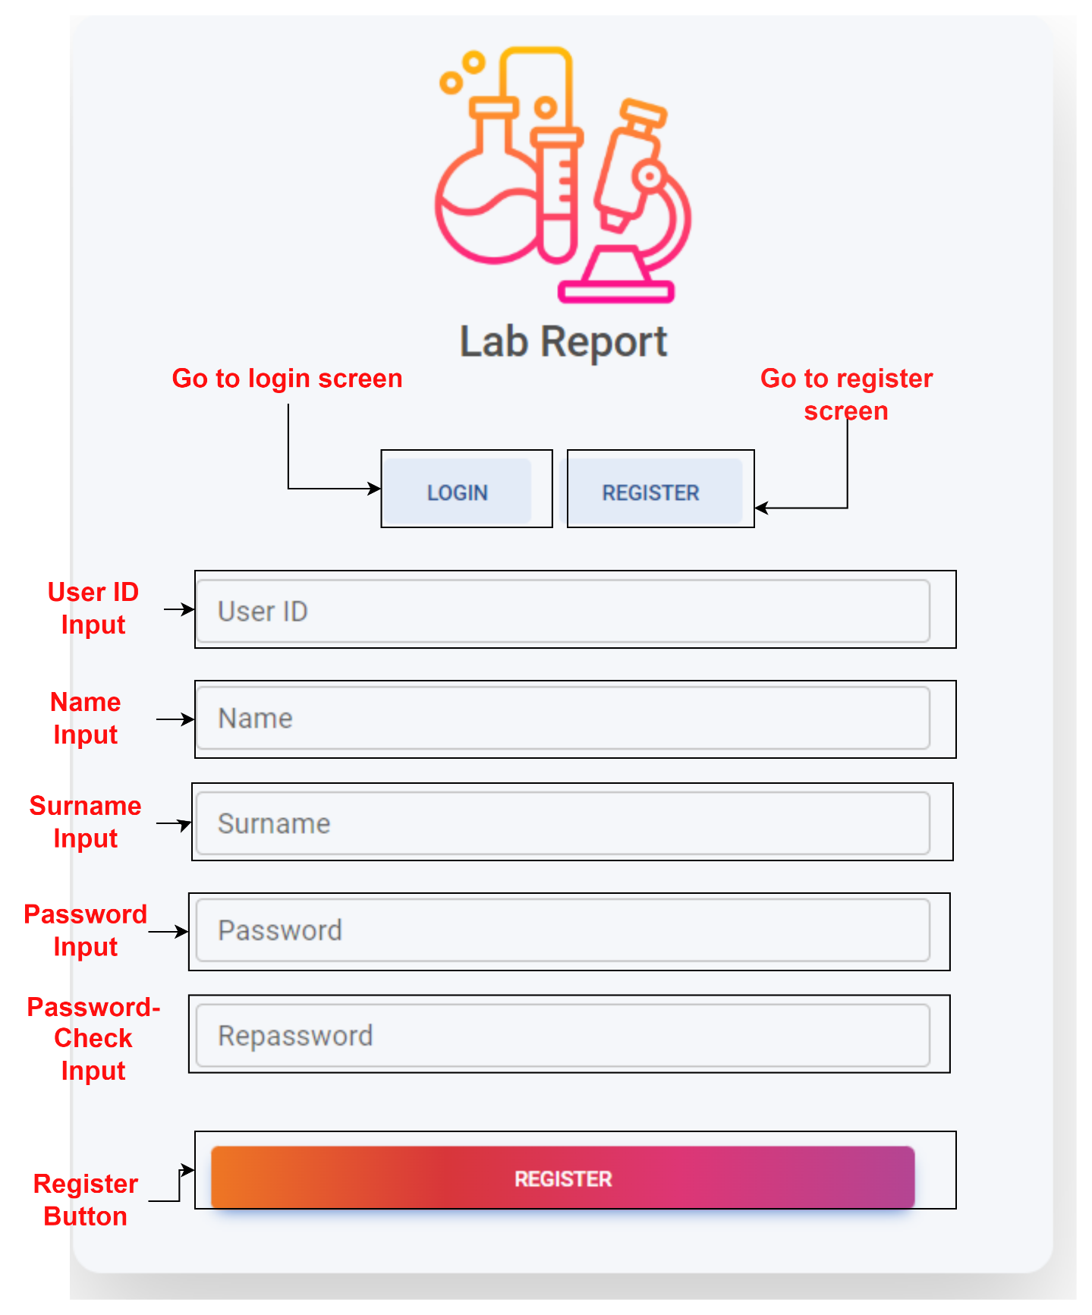

* + - 1. Patient Dashboard

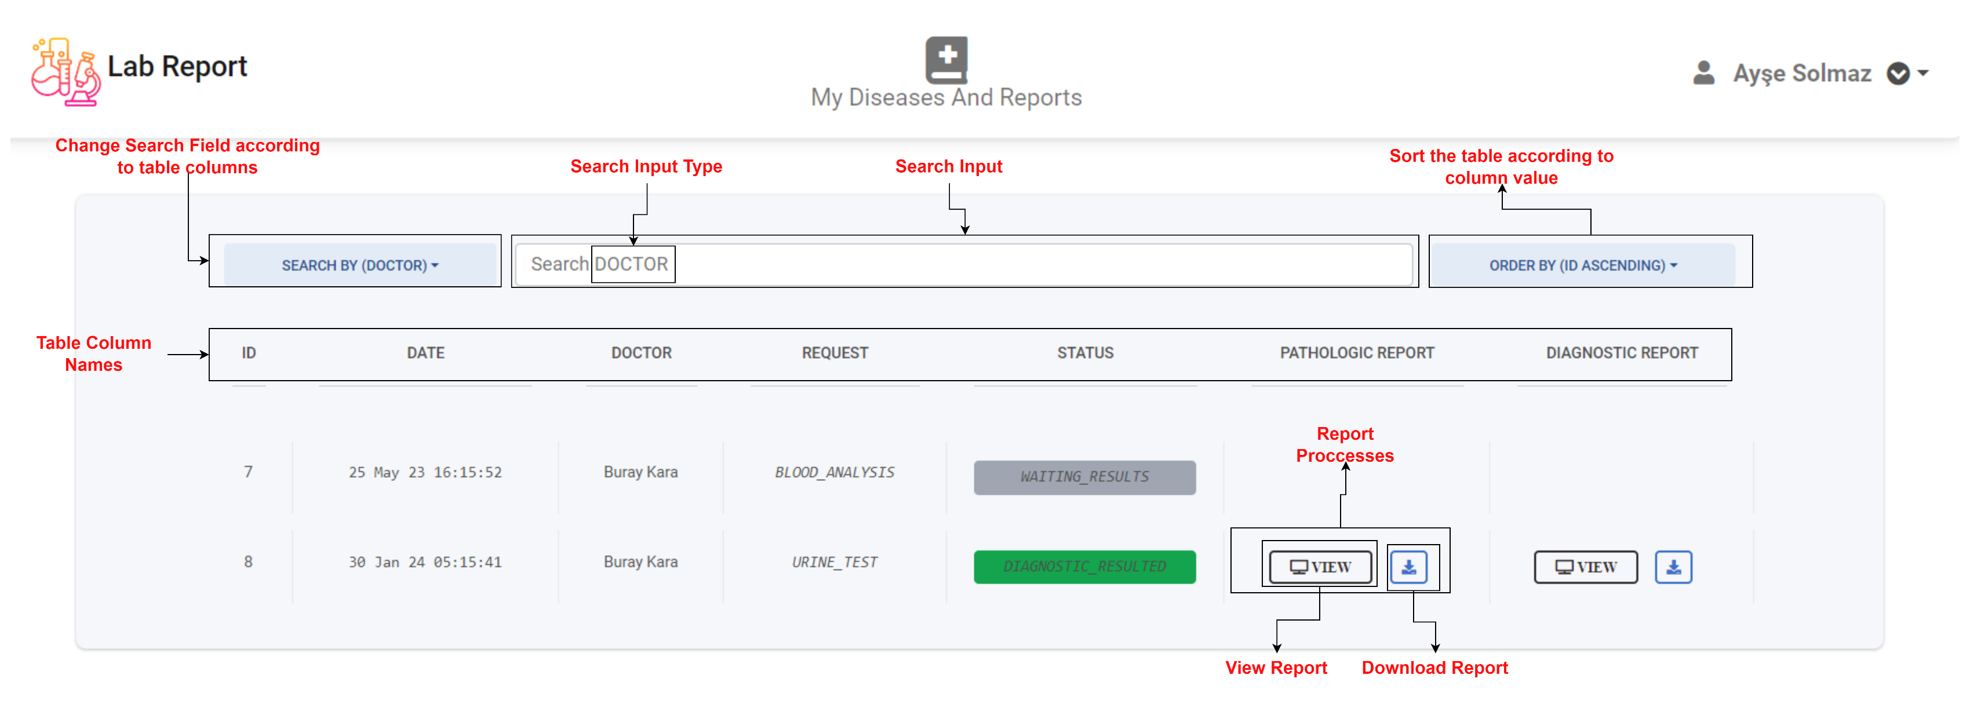

* + - 1. User Drop-Down

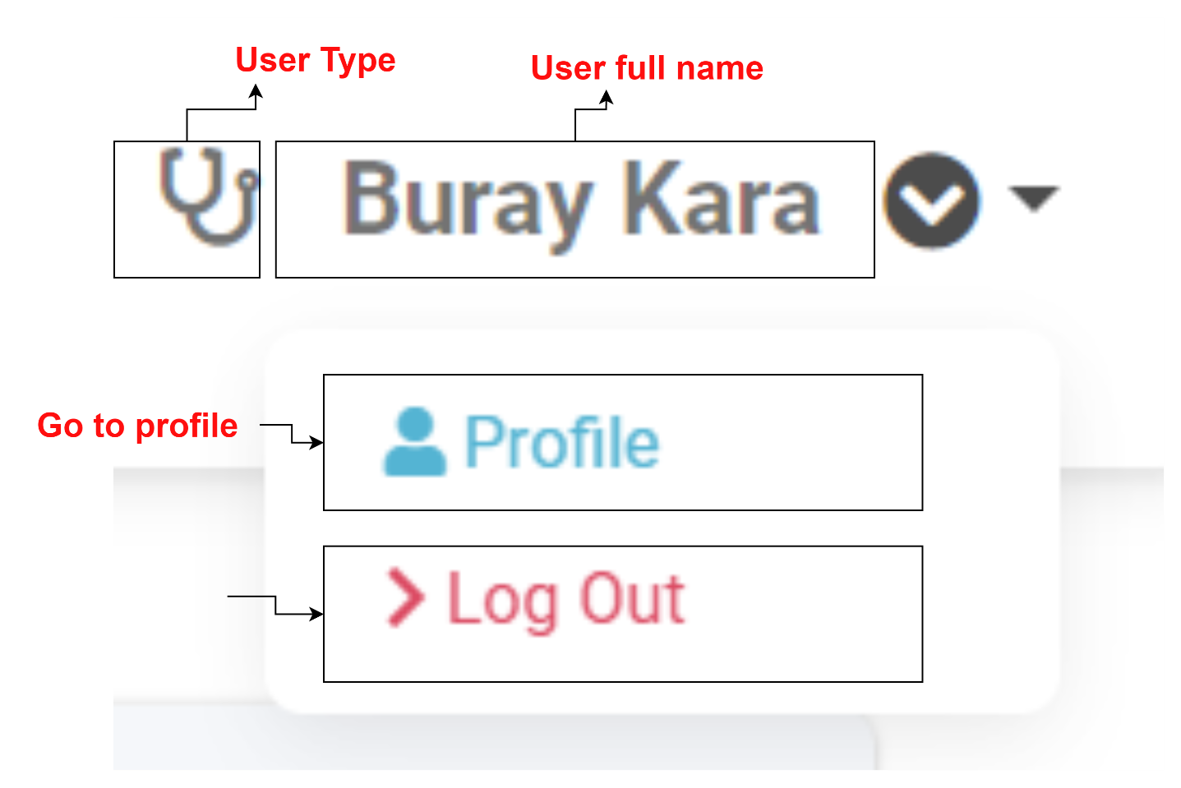

* + - 1. User Profile

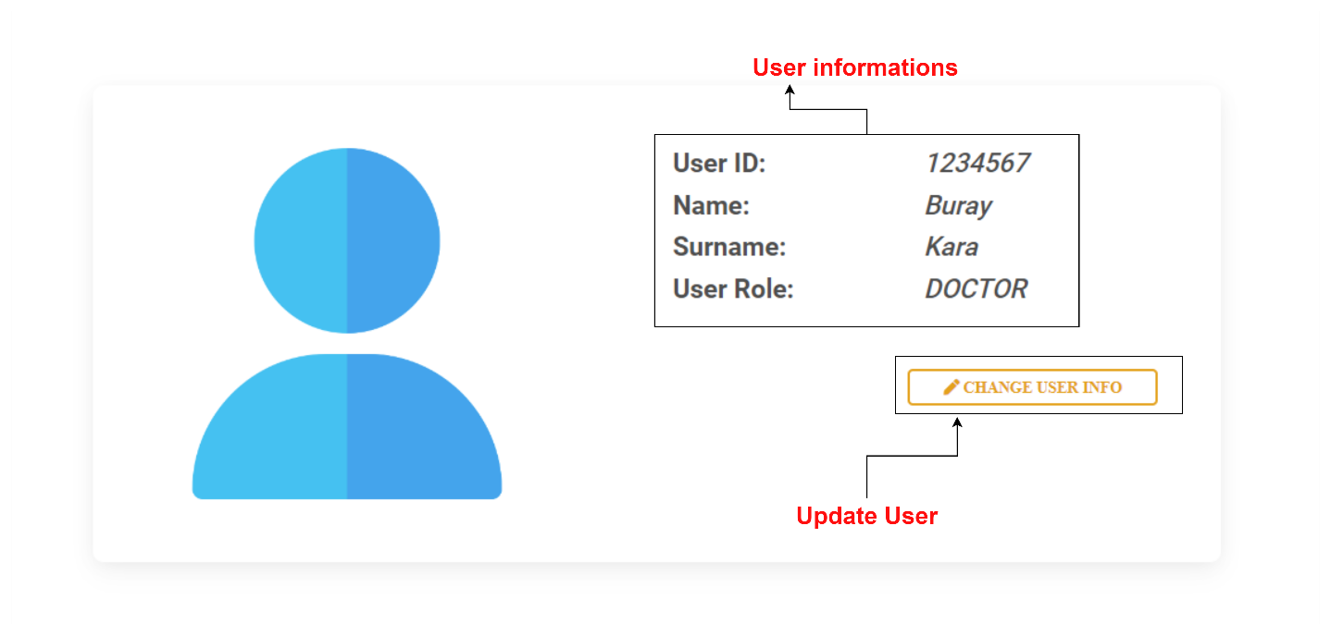

* + - 1. Update User

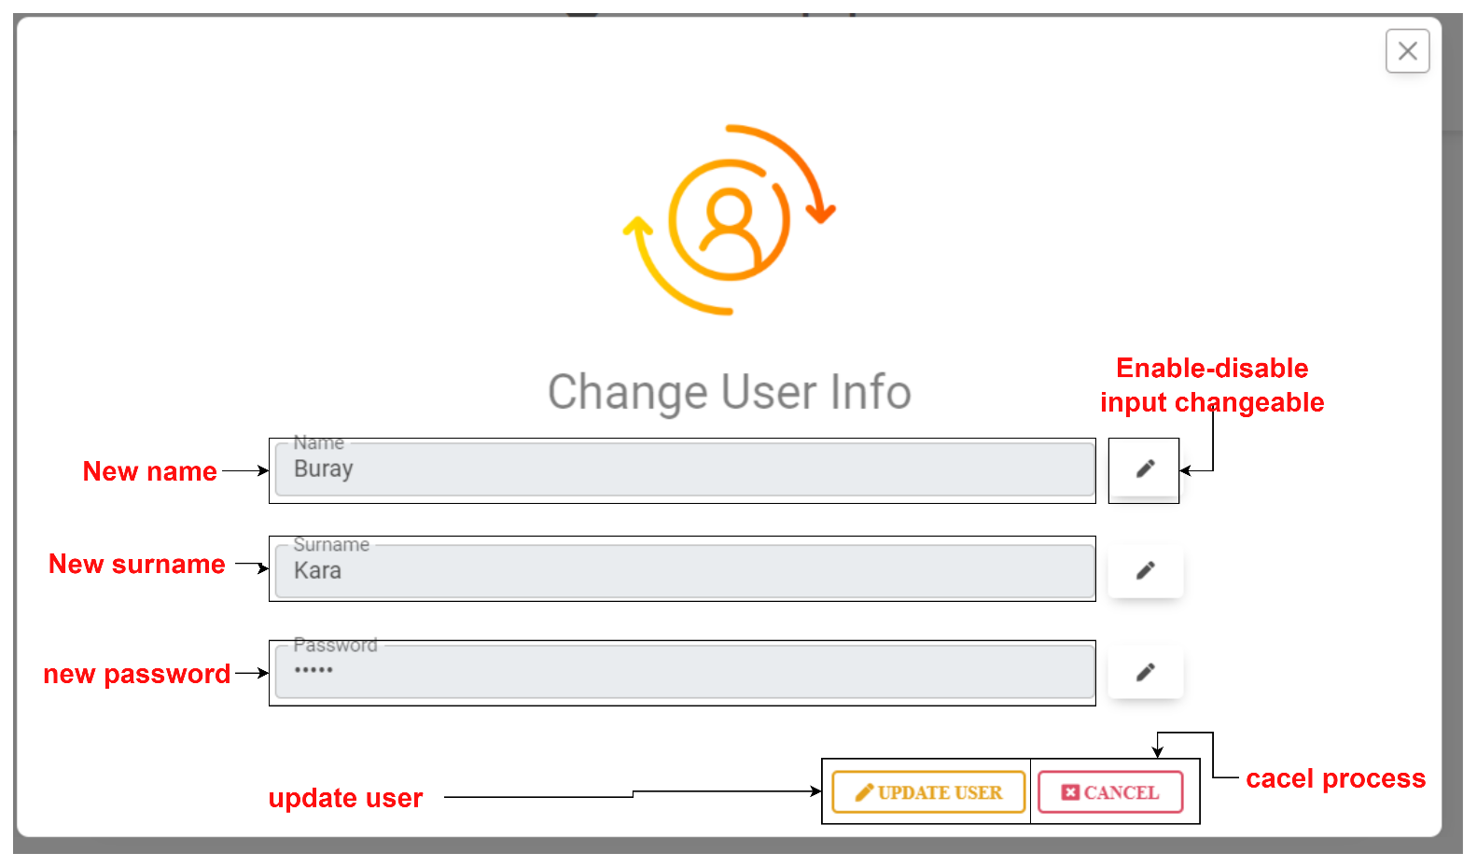

* + - 1. Are You Sure Modal

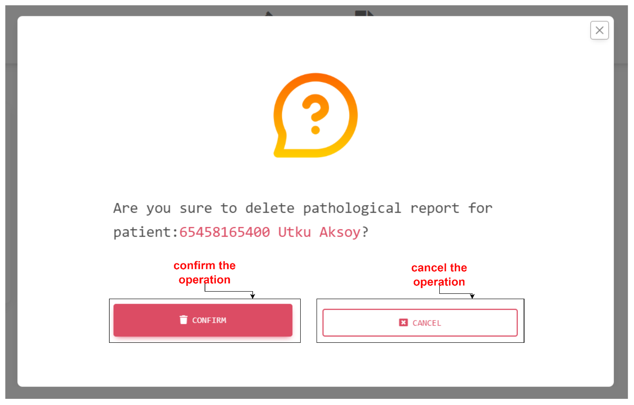

* + - 1. Doctor Dashboard

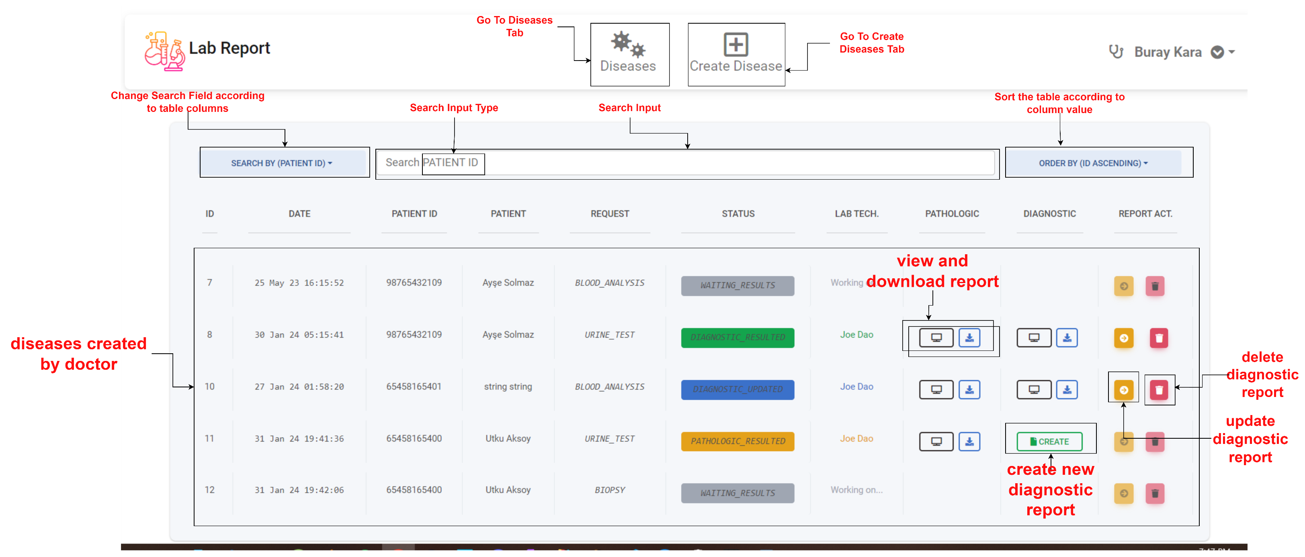

* + - 1. Create Disease

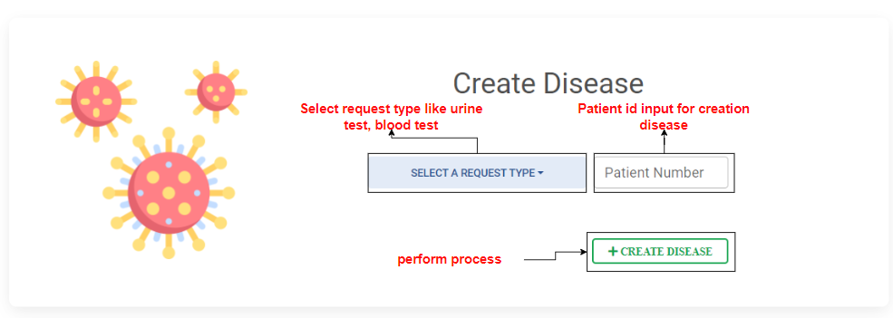

* + - 1. Create Diagnostic Report

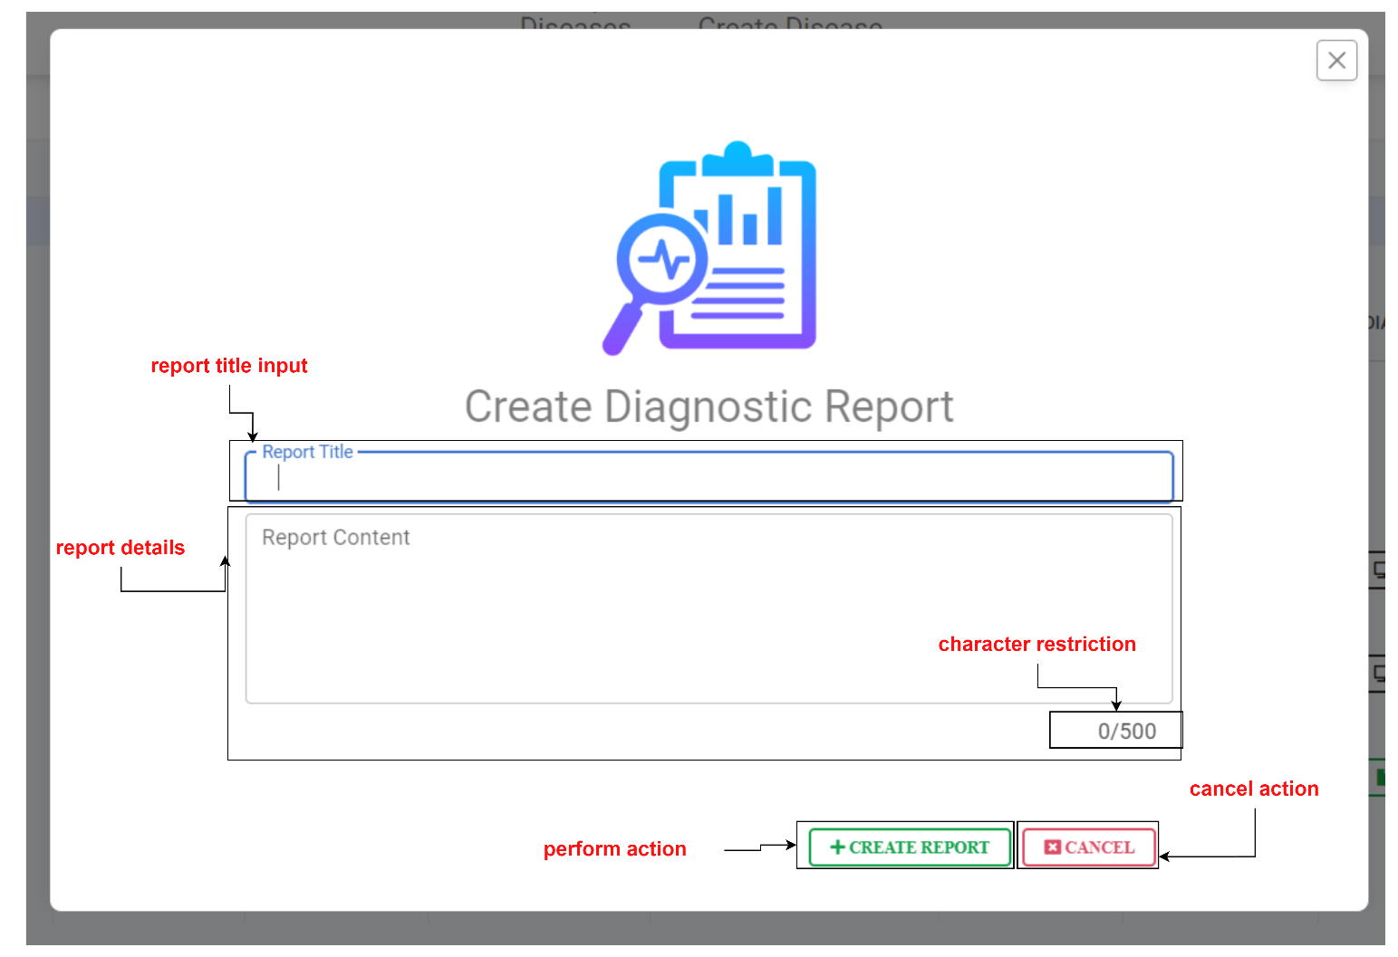

* + - 1. Update Diagnostic Report

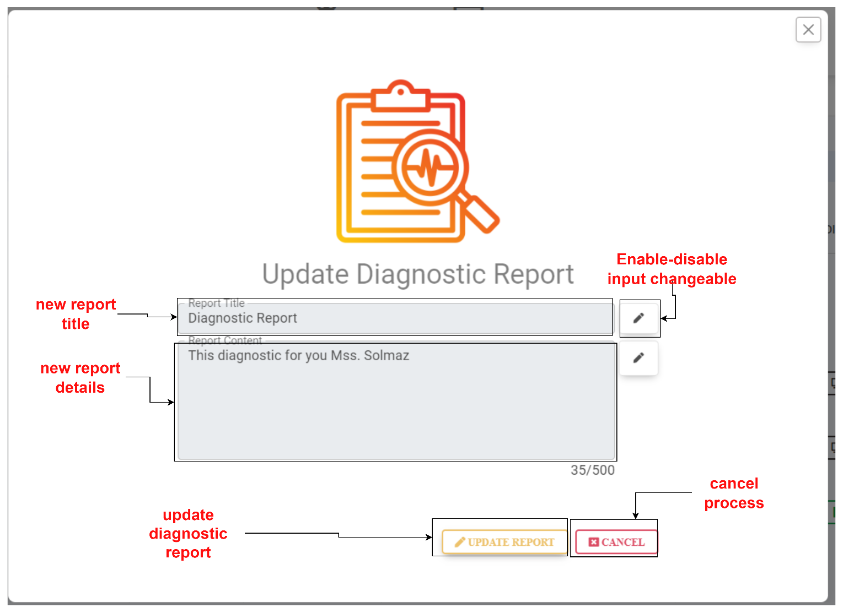

* + - 1. Lab Technician Dashboard

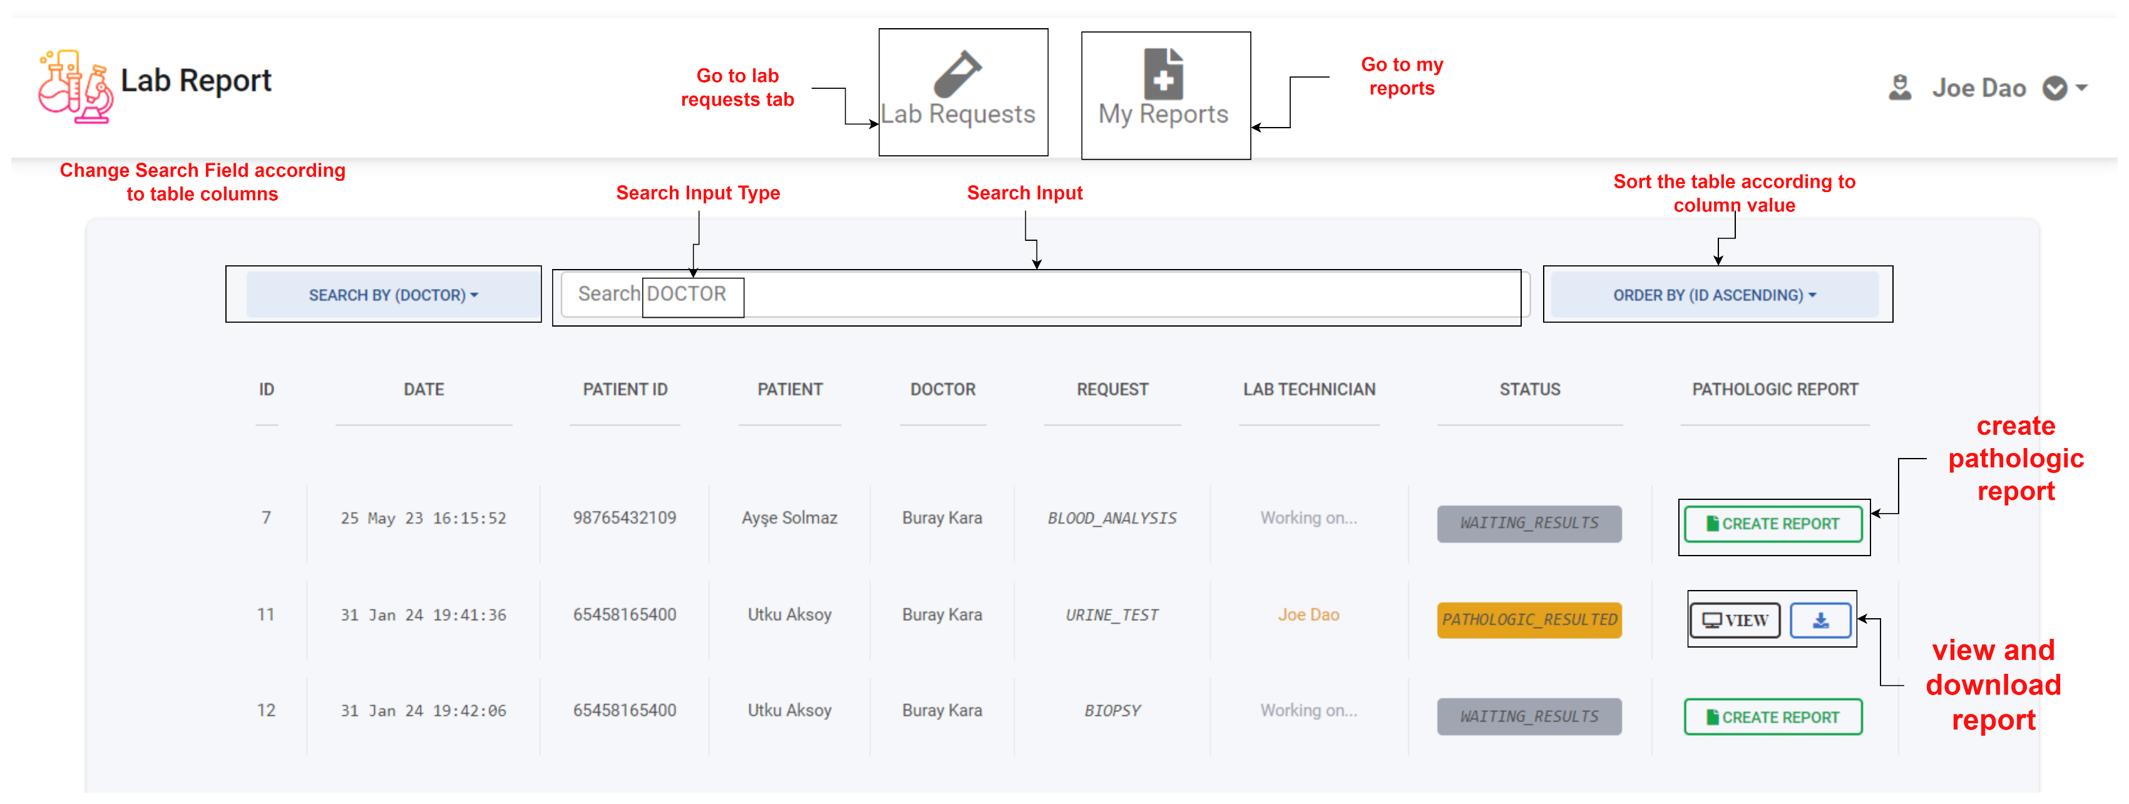

* + - 1. Create Pathologic Report

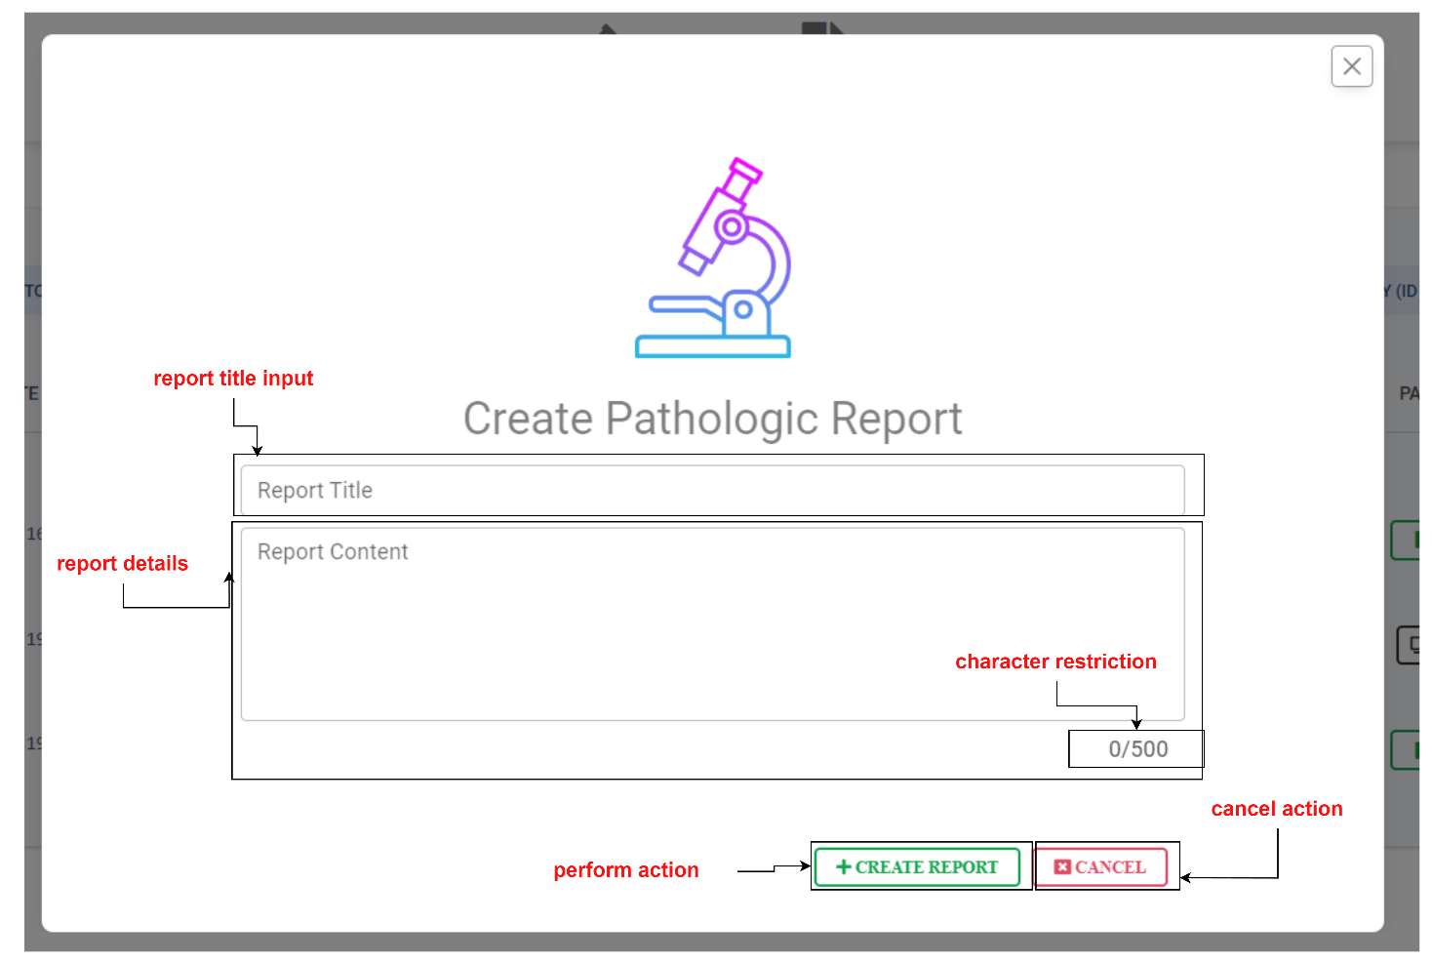

* + - 1. Update Pathologic Report

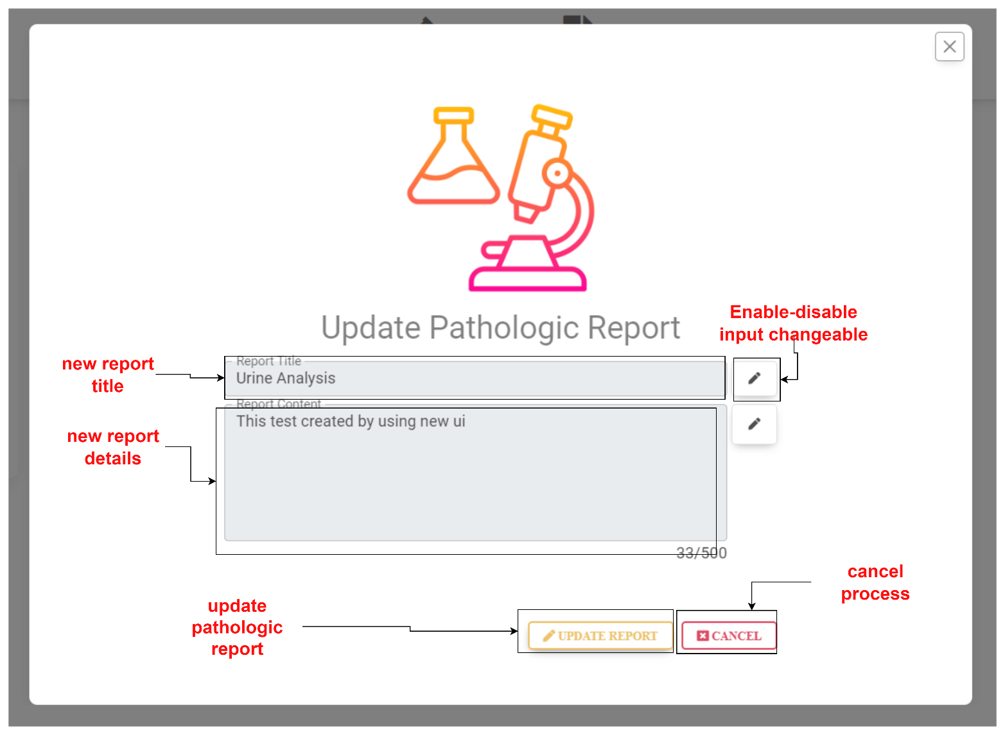

* + - 1. My Reports

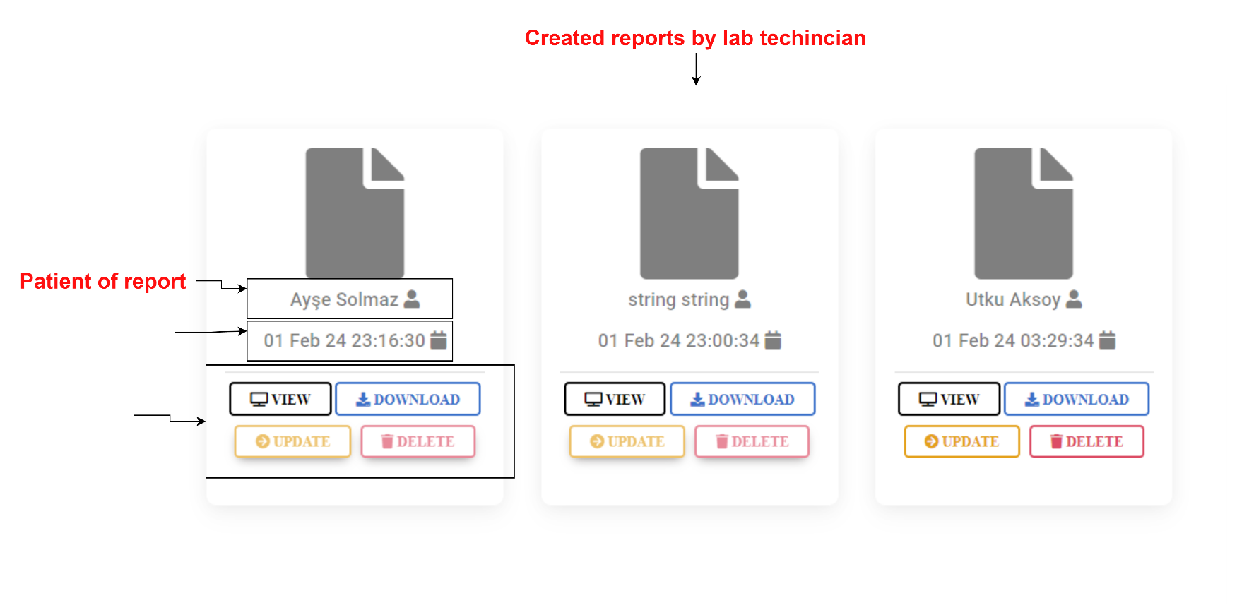

* + 1. Developing Tools
       1. Javascript

Javascript is a interpreted programming language and has plenty frameworks and libs. It is mostly using on web programming. I am going to use it to communicate with my Web API.

* + - 1. React.js

React is a Javascript based web and mobile framework. I am going to use it to develop web-frontend side of this project.

* + - 1. Bootstrap

Bootstrap is a Javascript based CSS library. We can design the html objects just giving them class name through this library.

* + - 1. Flaticon

Flaticon is web site providing a lot of free icon. I am going to use this web site to desing my interfaces.

* + - 1. FontAwesome

FontAwesome is a icon library contains many various icons.

* + - 1. React-Toastify

React-Toastify is a toast message library for web apps.

1. USER AUTHORIZATION

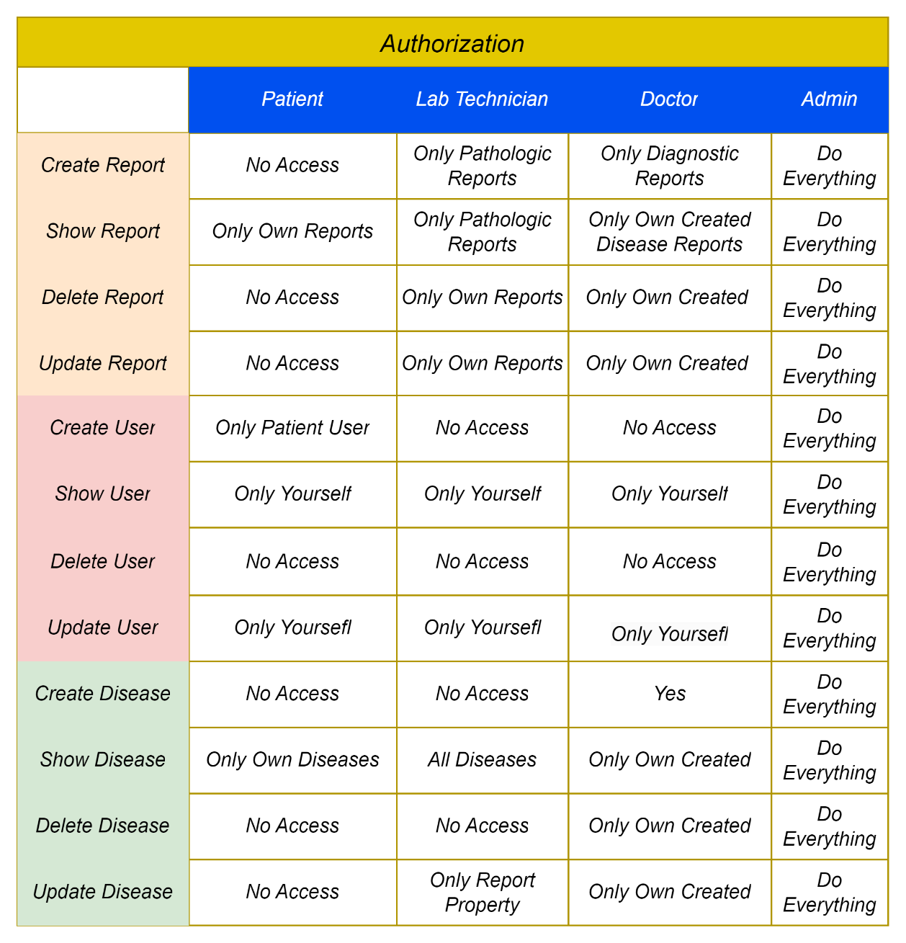

1. FILE STRUCTURE
   1. Web API

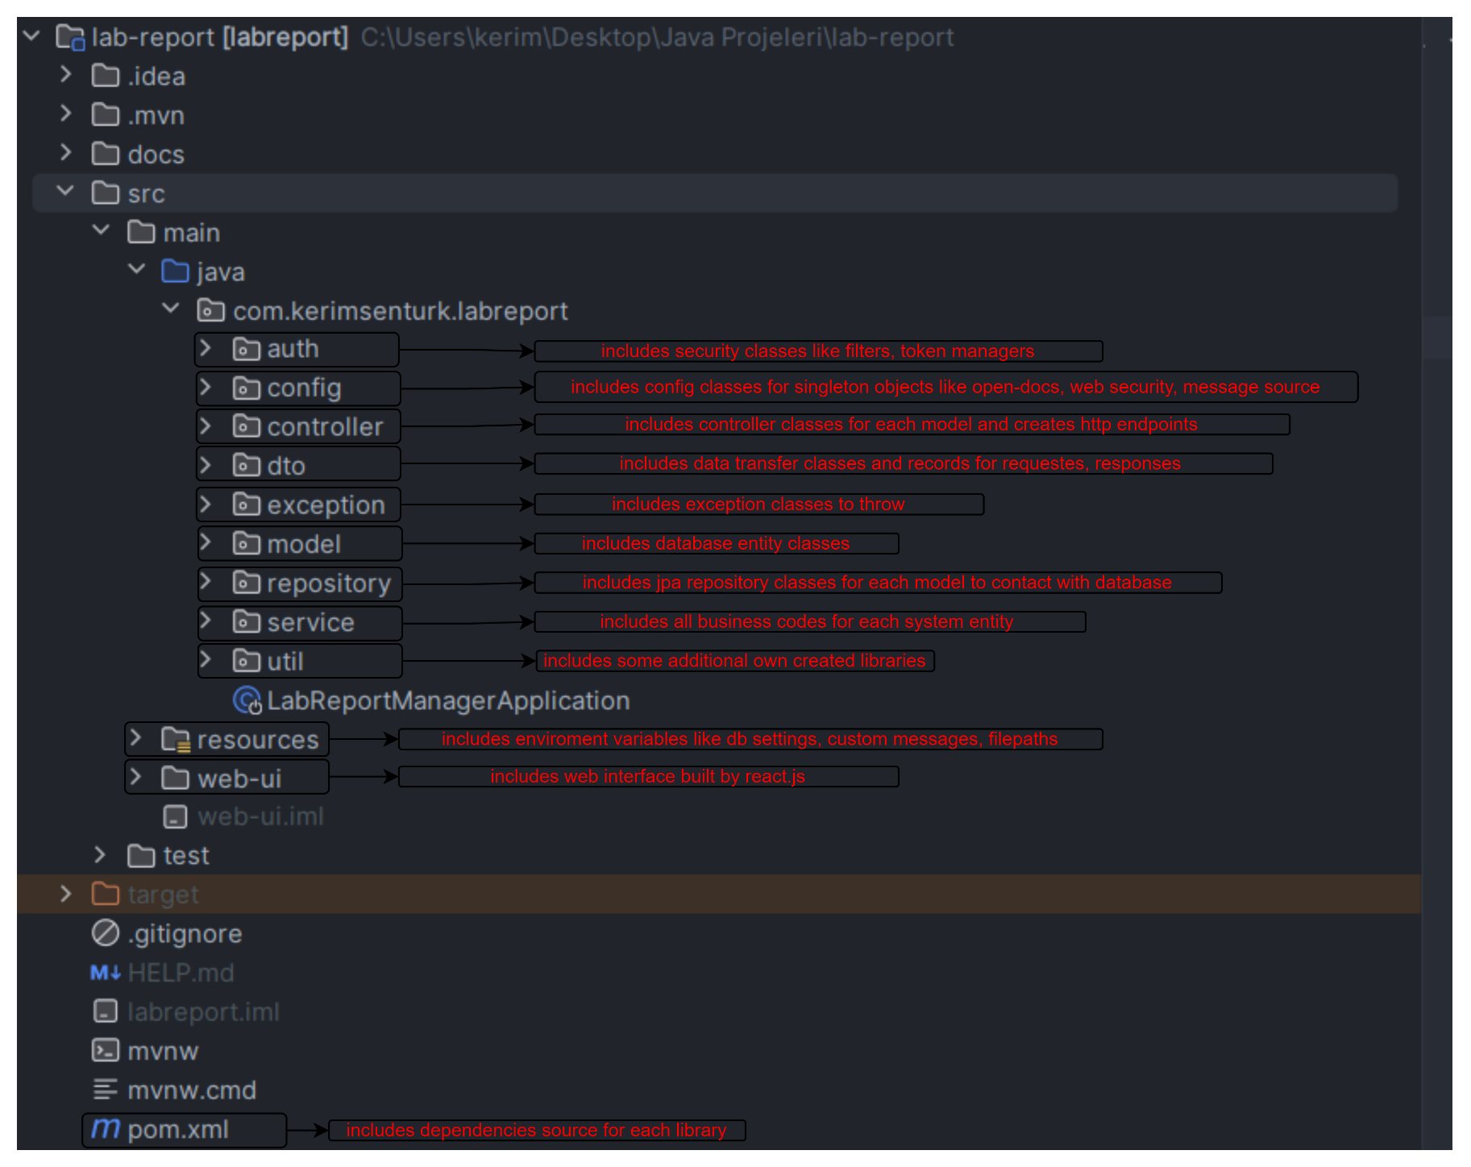

* 1. Web UI

